HAMMURABI

- Documentation -

Documentation - Turnover import

|  |  |  |  |
| --- | --- | --- | --- |
| **UPDATES** | | | |
| **Version** | **Date** | **Author** | **Comments** |
| 1.0 | 09/02/2016 | A. CORNELLE | Creation |
| 2.0 | 29/06/2016 | A. CORNELLE | Update due to enhancement on fictive references |
| 3.0 | 07/01/2019 | G. LETELU | Update to import sellout (due to “New PolCo” enhancement) |
|  |  |  |  |
|  |  |  |  |
|  |  |  |  |

Contents

1 RCC Import(BASE Global) 5

1.1 Instructions 5

1.2 Import fictive references 6

1.3 Turnover N 10

1.3.1 Get the data 10

1.3.1.1 Execution of the SQL procedure 10

1.3.1.2 Get the data in the table 10

1.3.2 Import the data to Hammurabi INTEGRATION 13

1.3.3 Import the data to Hammurabi PRODUCTION 16

1.4 Turnover N-1 17

1.4.1 Get the data 17

1.4.1.1 Execution of the SQL procedure 17

1.4.1.2 Get the data in the table 17

1.4.2 Import the data to Hammurabi INTEGRATION 20

1.4.3 Import the data to Hammurabi PRODUCTION 22

2 RDO Import (APARA) 23

2.1 Instructions 23

2.2 Turnover N 23

2.2.1 Get the data 23

2.2.2 Import the data to Hammurabi INTEGRATION 25

2.2.3 Import the data to Hammurabi PRODUCTION 27

2.3 Turnover N-1 28

2.3.1 Get the data 28

2.3.2 Import the data to Hammurabi INTEGRATION 30

2.3.3 Import the data to Hammurabi PRODUCTION 32

3 Sellout Import (sellout) 33

3.1 Instructions 33

3.2 Sellout N 33

3.2.1 Get the data 33

3.2.1.1 Execution of the SQL procedure 33

3.2.1.2 Get the data in the table 33

3.2.2 Import the data to Hammurabi INTEGRATION 34

3.2.3 Import the data to Hammurabi PRODUCTION 36

3.3 Sellout N-1 37

3.3.1 Get the data 37

3.3.1.1 Execution of the SQL procedure 37

3.3.1.2 Get the data in the table 37

3.3.2 Import the data to Hammurabi INTEGRATION 38

3.3.3 Import the data to Hammurabi PRODUCTION 40

# RCC Import

## Instructions

Each month, we receive a mail like it:

Bonjour,  
   
La MPC mise à jour à fin décembre 2015 est considérée validée.   
  
Vous trouverez donc le fichier Access "Base Globale" , contenant les données de décembre 2015 (Direct à fin décembre et Distribution à fin novembre):

* Sur le serveur Monet, dans le dossier «MesurePerfCommerciale /  BaseGlobaleRCC» sous le libellé Extract_Base_Globale_2015m12.zip.

**NB**: L'URL d'accès direct au dossier BaseGlobaleRCC sur Monet est la suivante  : <ftp://monet.fr.schneider-electric.com/BaseGlobaleRCC>.

* Sur le serveur CDS, dans le dossier CARCCN sous le libellé: Base_Globale_201512.txt

Nous vous rappelons qu'avec votre accord, le fichier 05 - Base globale n'est plus déposé.  
  
  
Cordialement,  
Mathilde  
____________________________________________________________________________________   
  
Support plate-forme QlikView SI PF    
[fr-mpc@schneider-electric.com](mailto:fr-mpc@schneider-electric.com)  
Tél SI PF : 04 38 24 16 52



Generally, when we receive this mail, we have to wait one day to have the GO of the customer (Natacha BLONDIN) to import the data in Hammurabi.

## Import fictive references

1. Go on the box: <https://app.box.com/login>

2. Click on « MPC – Tables des DCM » folder

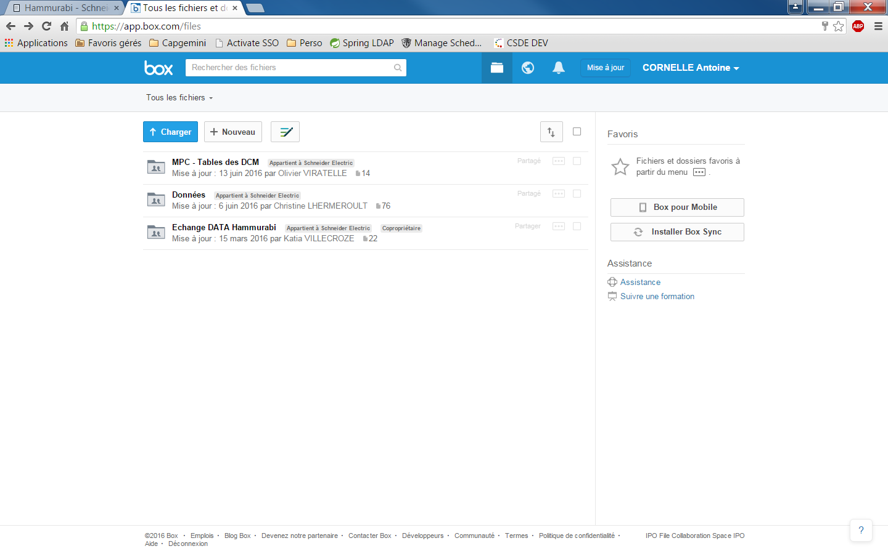

3. Search the file “Tables AJP Nat.xlsx”.

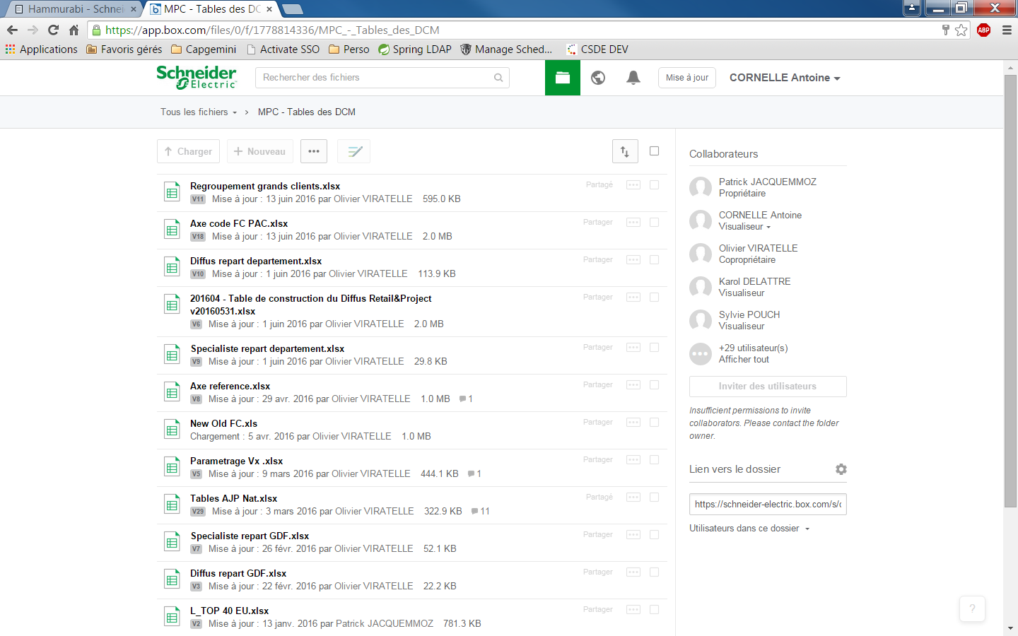

4. Download this file and open it in Excel.

5. Open a new Excel file in a second window.

6. Select all the data in the sheet “Liste TRI BDG pr AJP Nat”

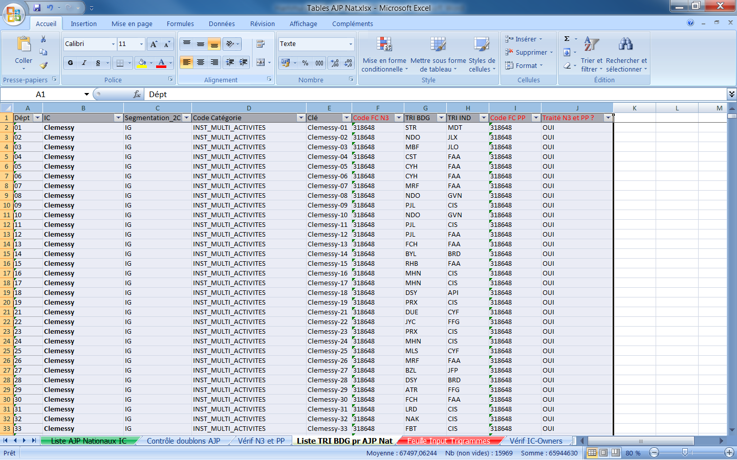

7. Copy it and paste it in the new file.

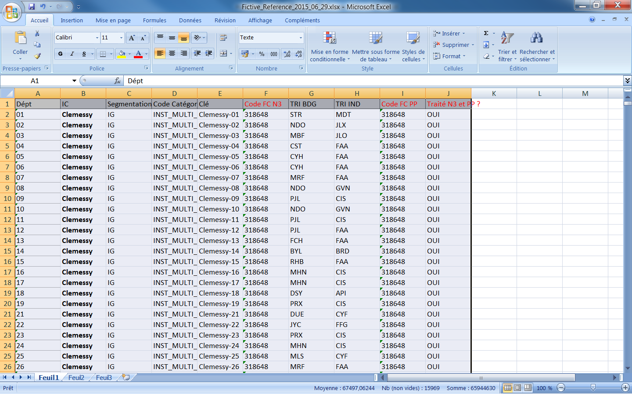

8. Save it

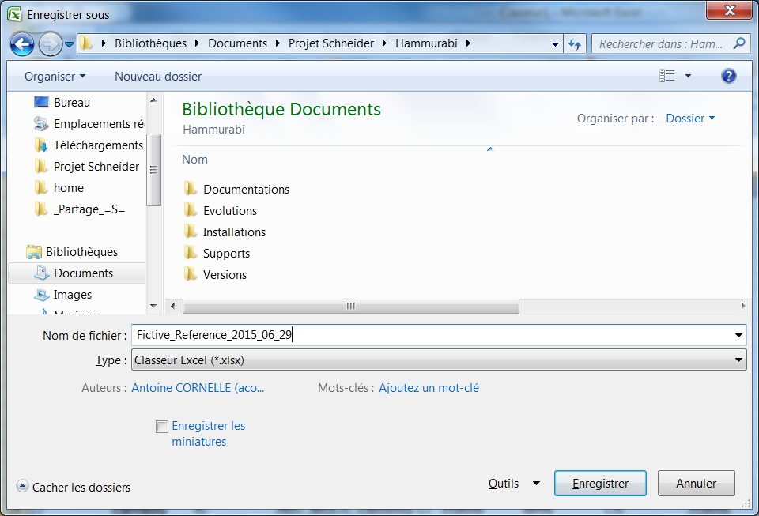

9. Go to Hammurabi (Admin user)

10. Go to the screen Administration 🡪 Données de reference 🡪 Renvois fictifs

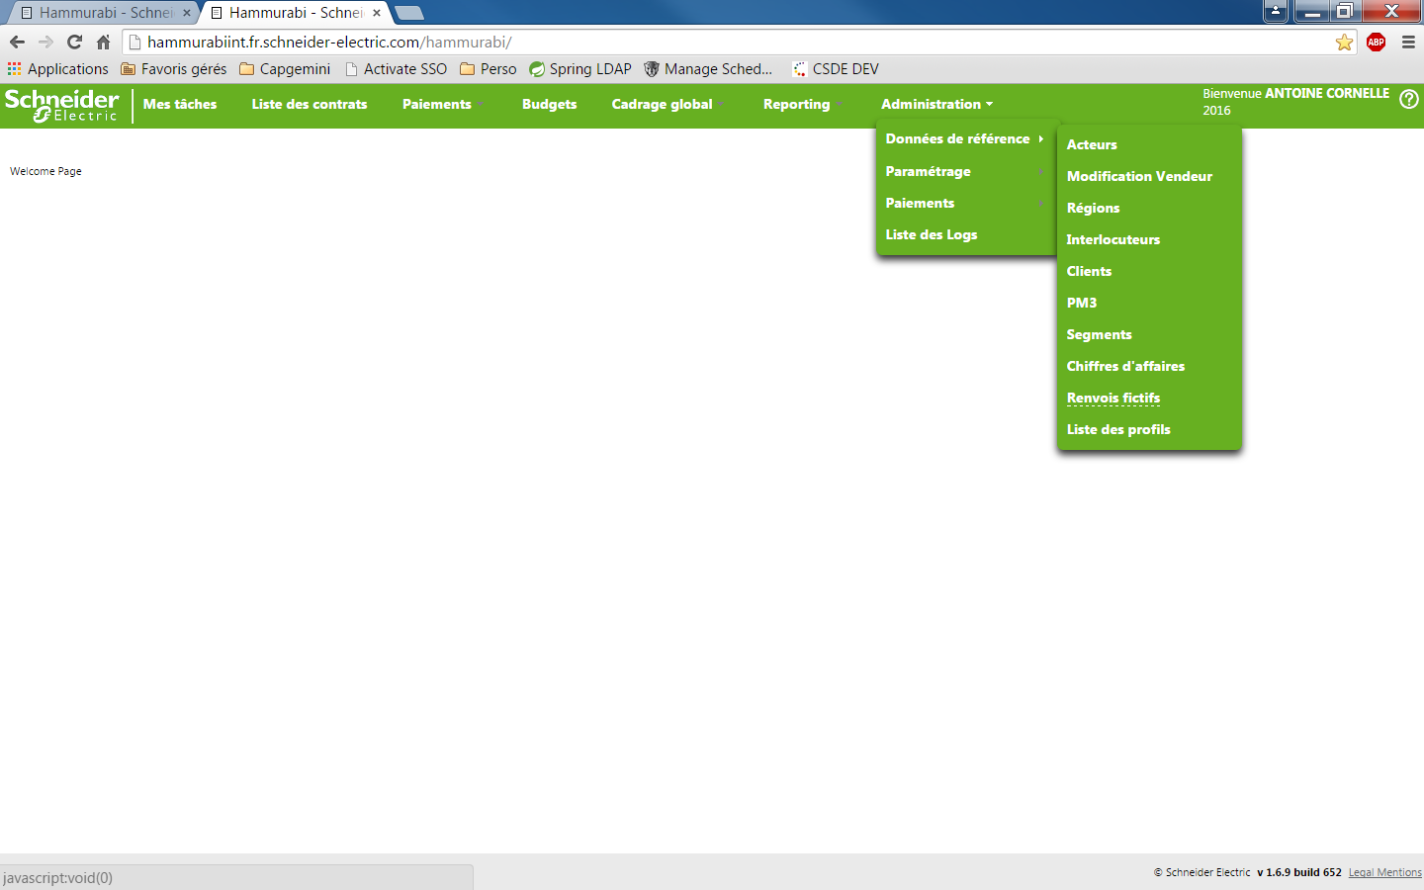

10. Click on the button “Importer un fichier”

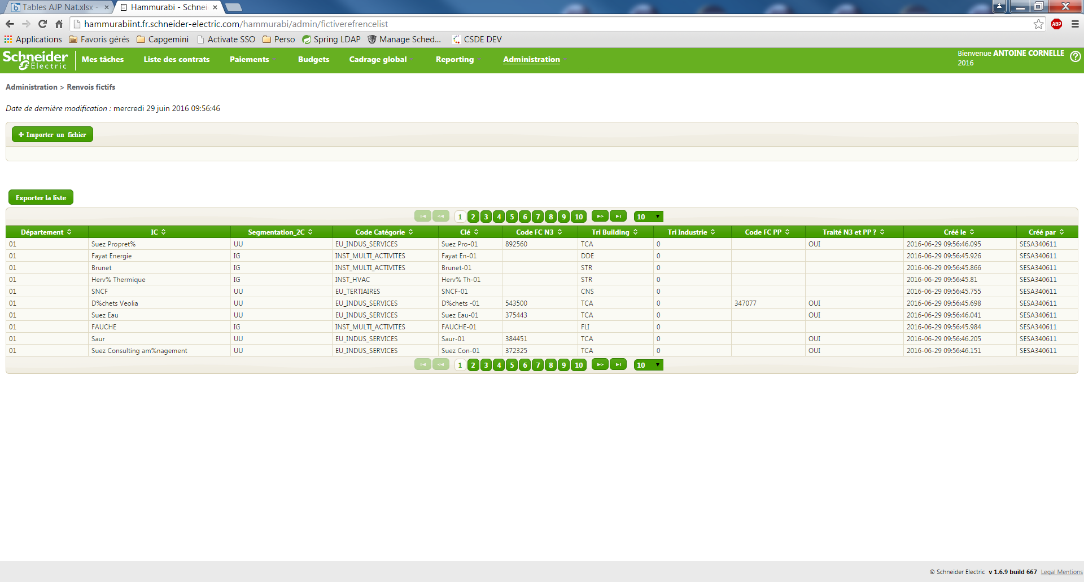

11. Choose your file and click on “Open” button

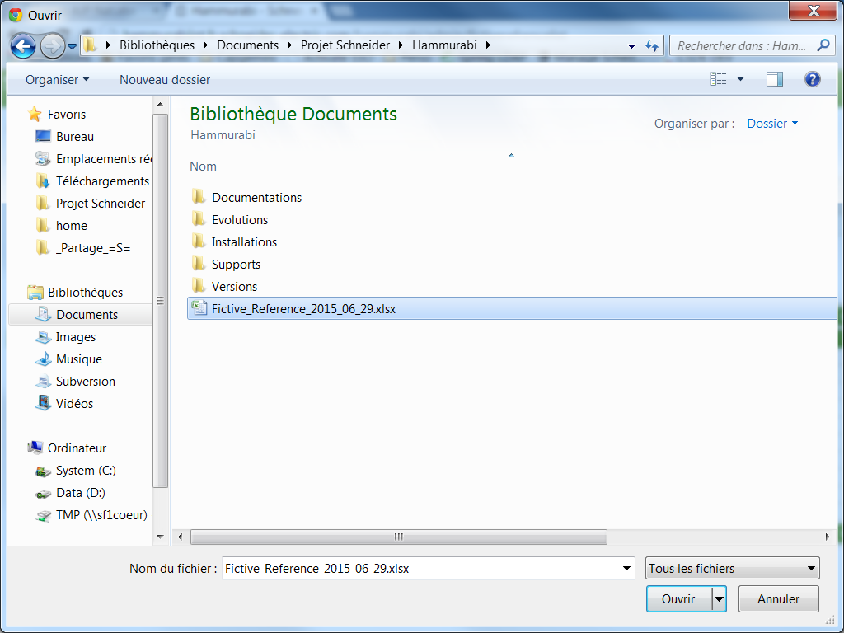

12. When the import is finished, a message is displayed:

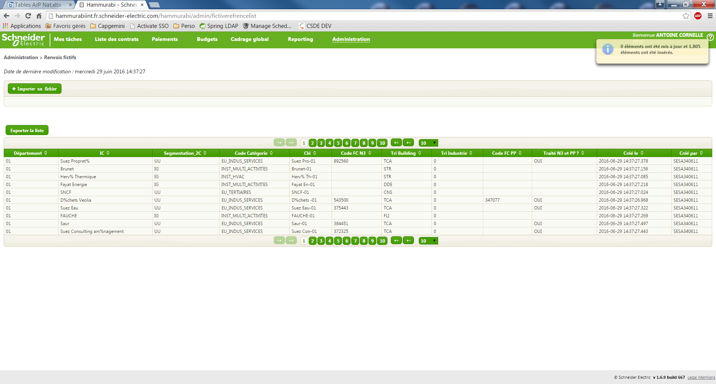

## Turnover N

### Get the data

/!\ You need an Oracle version which propose the delimited export like the following example.

/!\ You need an Oracle with the decimal delimiter “,”

#### Execution of the SQL procedure

To extract the data, you have to execute the following SQL request in Hammurabi PRODUCTION database (/!\ You must change the value in yellow by the month and the year)

execute EXTRACT_RCC_N('2016', '05');

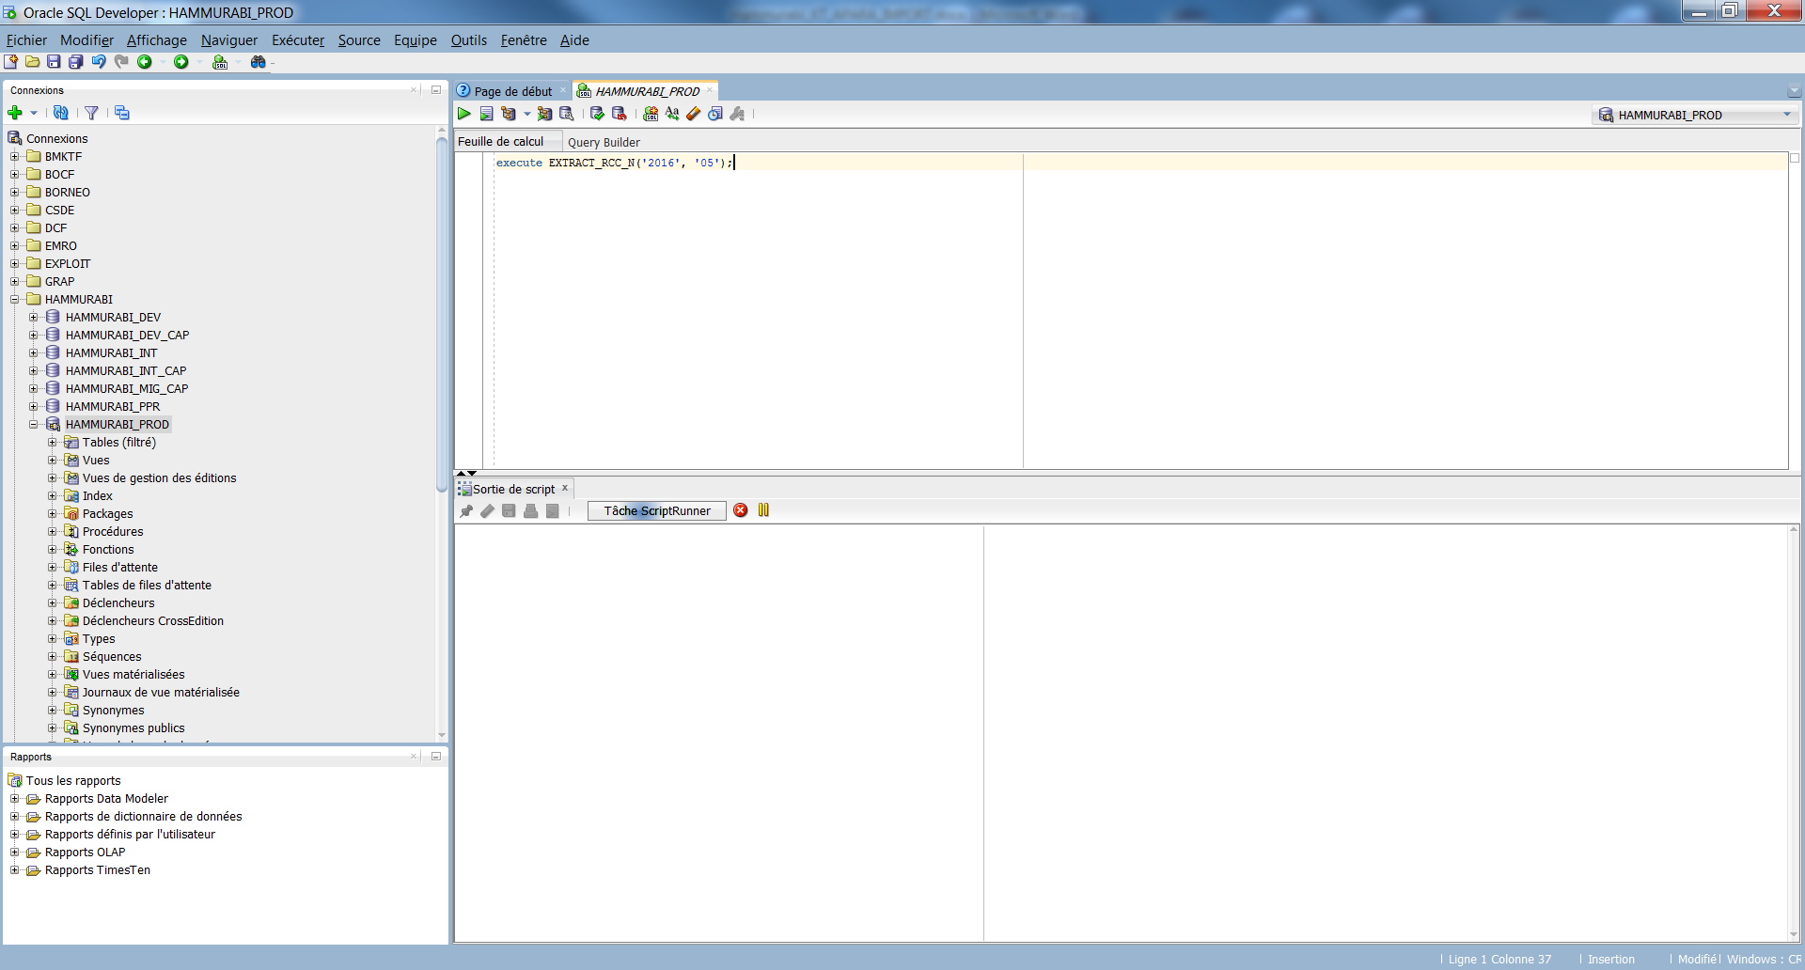

#### Get the data in the table

Execute the following command to get the data.

select * from T_EXTRACT_RCC_N

order by EXT_CODEFC, EXT_GDF;

Right click on the generated table and click on export

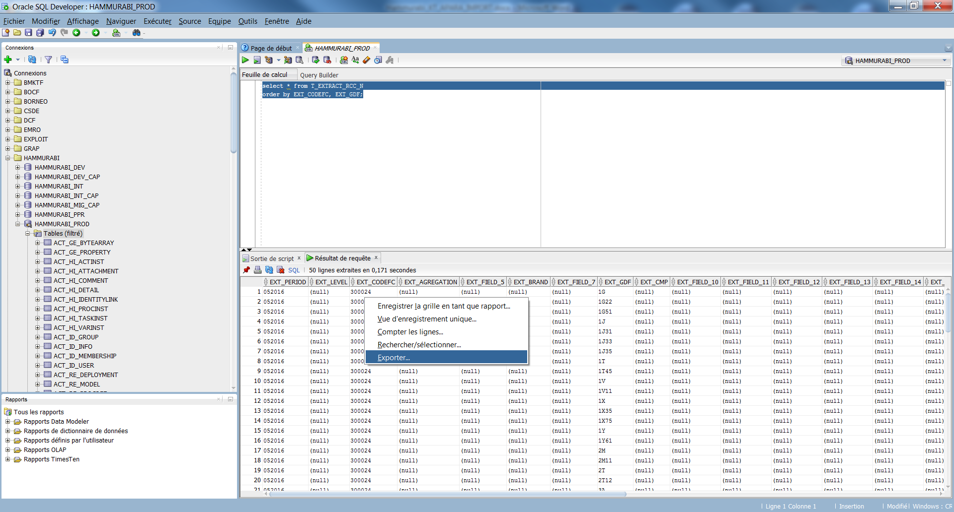

About the export:

* Format: delimited
* Header: YES
* Delimiter: “;”
* Left delimitation: nothing
* Right delimitation: nothing

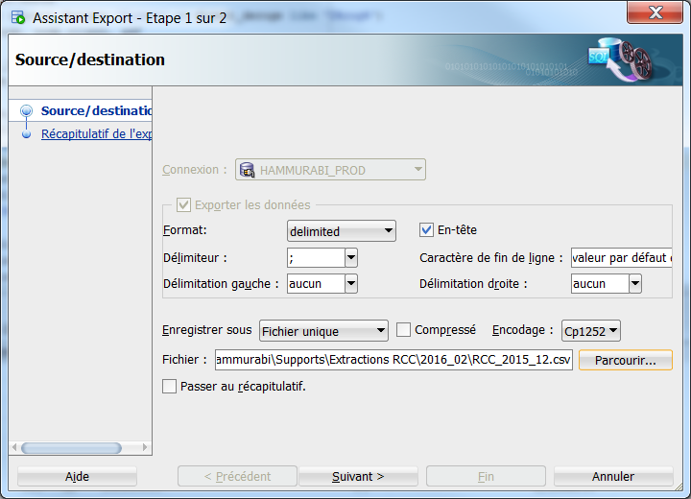

Click on “Browse” button

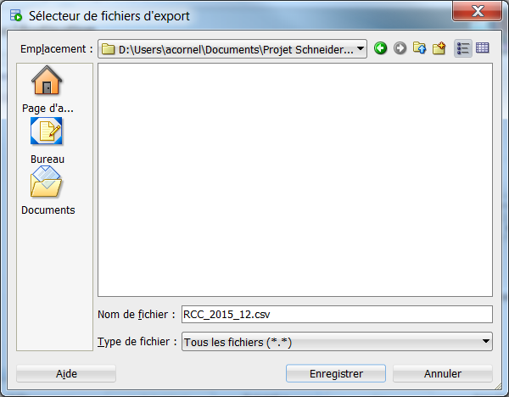

**/!\ The file must be saved with the extension “.csv”**

**Note :- open the export_sellout.csv file and replace the . with ,**

Wait for the end of execution.

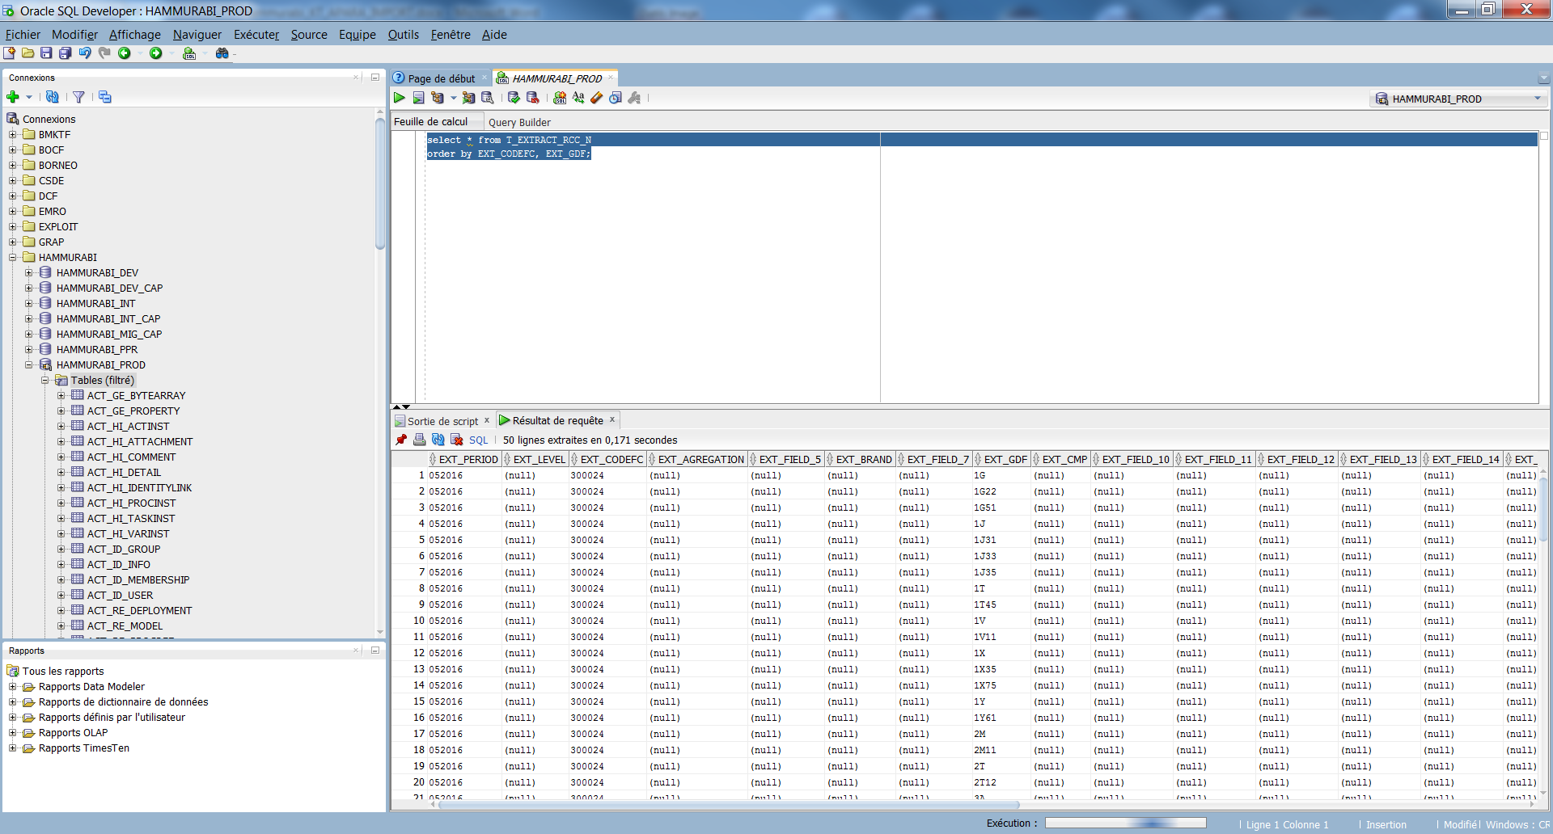

### Import the data to Hammurabi INTEGRATION

1. Go to [**http://hammurabiint.fr.schneider-electric.com/**](http://hammurabiint.fr.schneider-electric.com/) (Admin user)

2. Go on Administration tab 🡪 Données de référence 🡪 Chiffres d’affaires

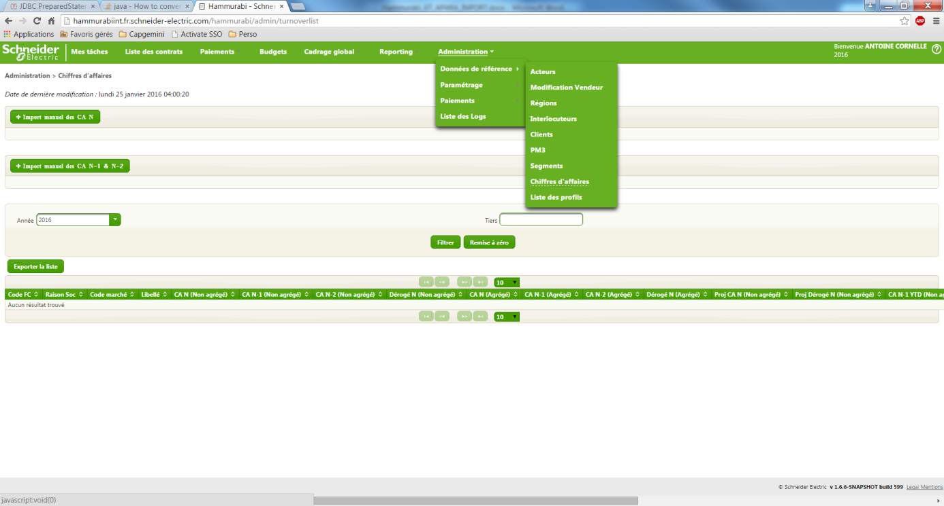

3. Click on « Import manuel des CA N » button

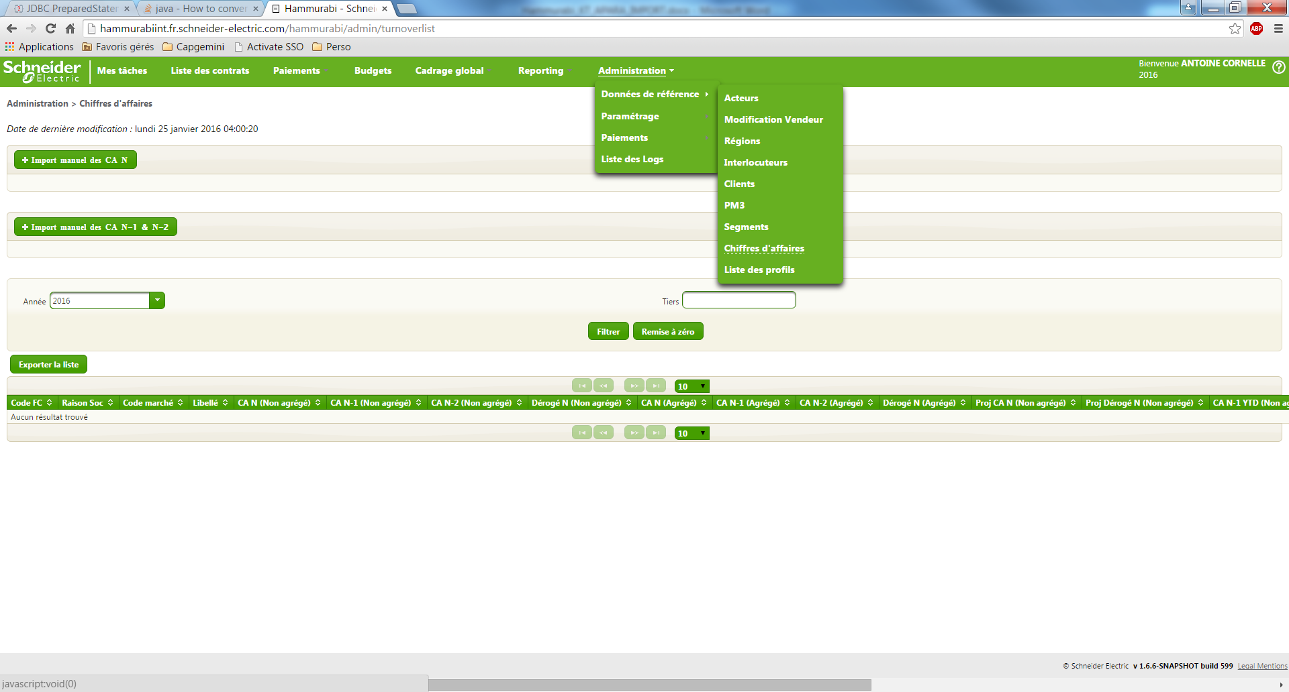

4. Choose your file and click on “Open” button

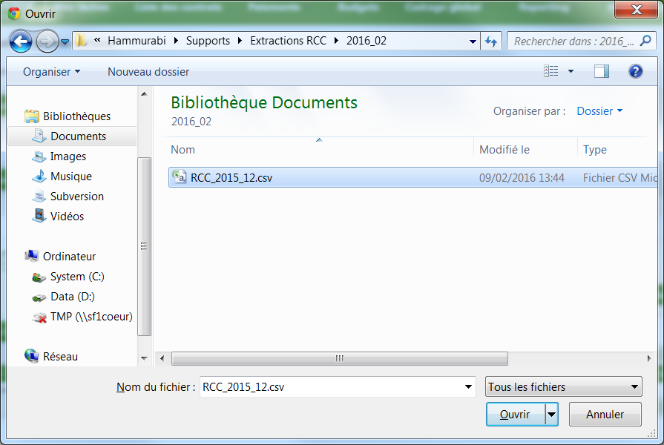

The loading begins. This operation can last up to 15 minutes.

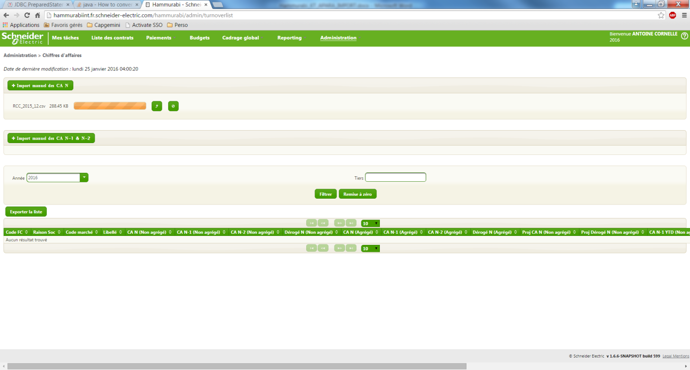

5. When the operation is finished, refresh the page. If the import is OK, you’ll see the new date of modification (today).

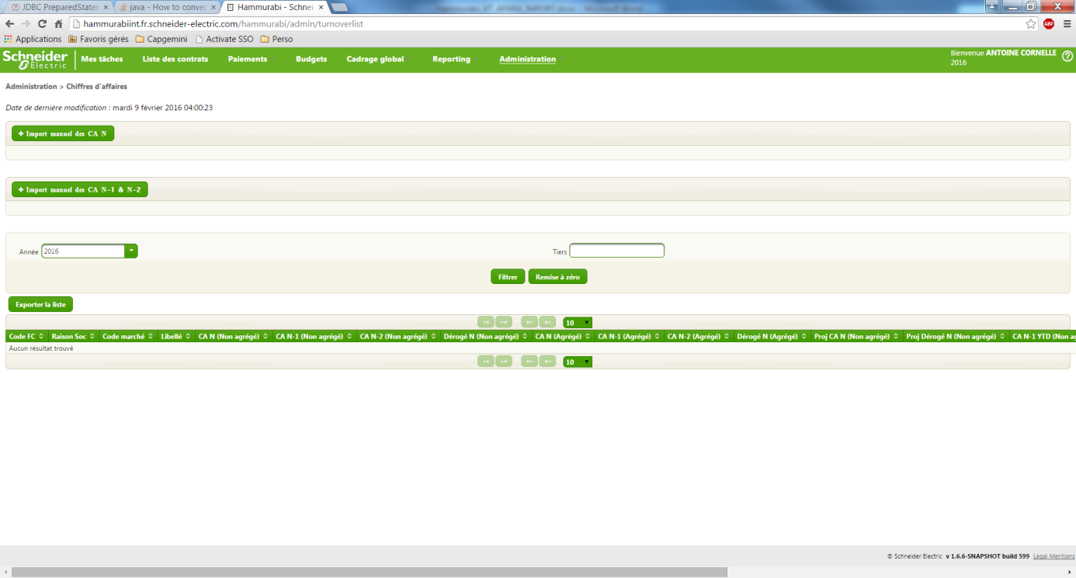

6. Go on the hidden page: <http://hammurabiint.fr.schneider-electric.com/hammurabi/faces/hidden/hidden.xhtml>

7. Click on “Réinitialiser les CA projetés” button.

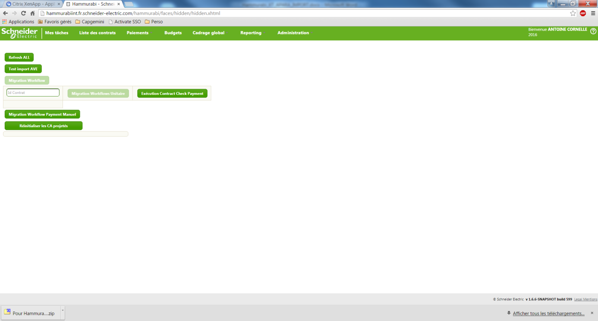

When the action is finished, the progress bar is at 100% and a popup is displayed

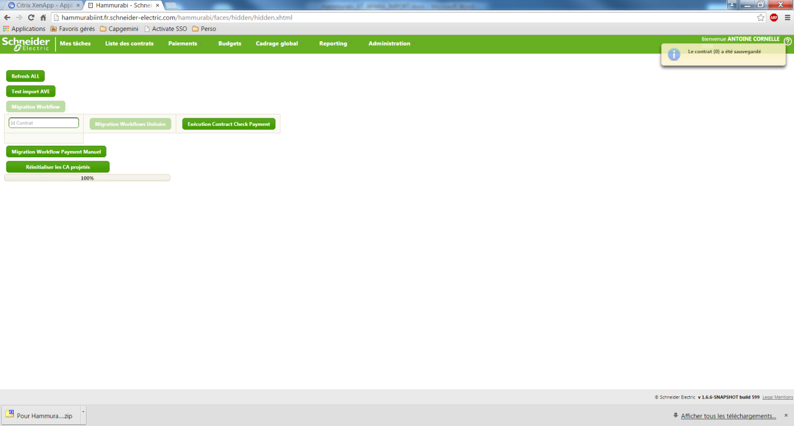

8. Send an email to the key user (Natacha BLONDIN) to say her that the import in INTEGRATION is finished.

### Import the data to Hammurabi PRODUCTION

**When you have the confirmation of the key user to import the file in production and ONLY when you have this confirmation**, do the same think in production like you have done in INTEGRATION.

URL: [**http://hammurabi.fr.schneider-electric.com/**](http://hammurabi.fr.schneider-electric.com/)

**ID: sesa111852 / soleil**

**Hidden page:** <http://hammurabi.fr.schneider-electric.com/hammurabi/faces/hidden/hidden.xhtml>

When it is finished, send an email to the key user (Natacha BLONDIN) to say her that the import in PRODUCTION is finished.

## Turnover N-1

### Get the data

/!\ You need an Oracle version which propose the delimited export like the following example.

/!\ You need an Oracle with the decimal delimiter “,”

#### Execution of the SQL procedure

To extract the data, you have to execute the following SQL request in Hammurabi PRODUCTION database (/!\ You must change the value in yellow by the year N-1)

execute EXTRACT_RCC_N1('2015');

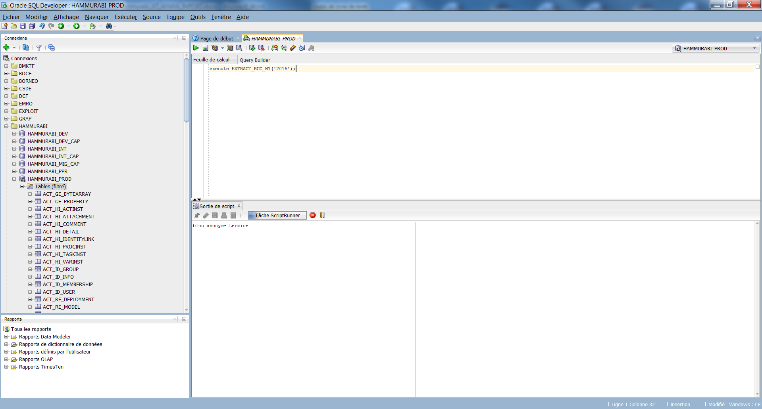

#### Get the data in the table

Execute the following command to get the data.

select * from T_EXTRACT_RCC_N1

order by EXT_CODEFC, EXT_GDF;

Right click on the generated table and click on export



About the export:

* Format: delimited
* Header: YES
* Delimiter: “;”
* Left delimitation: nothing
* Right delimitation: nothing



Click on “Browse” button



**/!\ The file must be saved with the extension “.csv”**

**Note :- open the export_sellout.csv file and replace the . with ,**

Wait for the end of execution.



### Import the data to Hammurabi INTEGRATION

1. Go to [**http://hammurabiint.fr.schneider-electric.com/**](http://hammurabiint.fr.schneider-electric.com/) (Admin user)

2. Go on Administration tab 🡪 Données de référence 🡪 Chiffres d’affaires



3. Click on « Import manuel des CA N-1 & N-2 » button

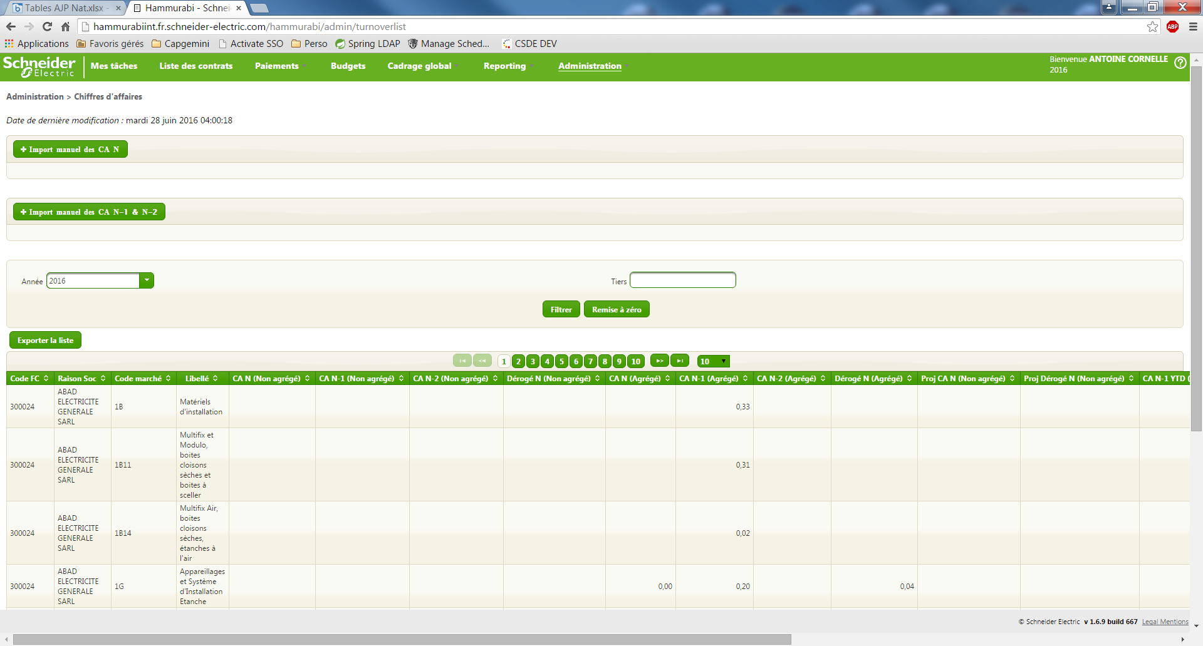

4. Choose your file and click on “Open” button



The loading begins. This operation can last up to 15 minutes.

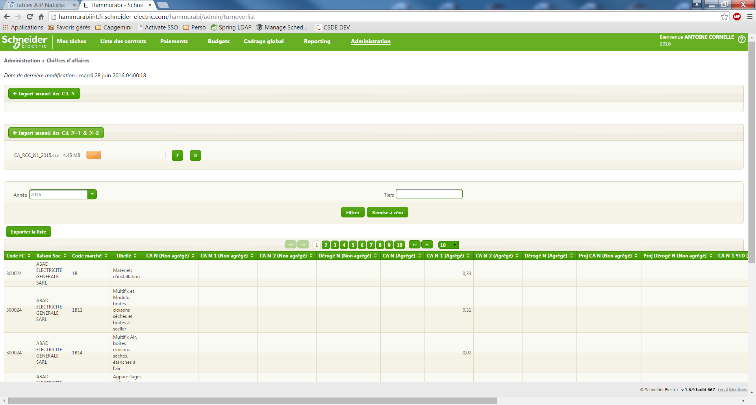

5. When the operation is finished, refresh the page. If the import is OK, you’ll see the new date of modification (today).



6. Go on the hidden page: <http://hammurabiint.fr.schneider-electric.com/hammurabi/faces/hidden/hidden.xhtml>

7. Click on “Réinitialiser les CA projetés” button.



When the action is finished, the progress bar is at 100% and a popup is displayed



8. Send an email to the key user (Natacha BLONDIN) to say her that the import in INTEGRATION is finished.

### Import the data to Hammurabi PRODUCTION

**When you have the confirmation of the key user to import the file in production and ONLY when you have this confirmation**, do the same think in production like you have done in INTEGRATION.

URL: [**http://hammurabi.fr.schneider-electric.com/**](http://hammurabi.fr.schneider-electric.com/)

**ID: sesa111852 / soleil**

**Hidden page:** <http://hammurabi.fr.schneider-electric.com/hammurabi/faces/hidden/hidden.xhtml>

When it is finished, send an email to the key user (Natacha BLONDIN) to say her that the import in PRODUCTION is finished.

# ­RDO Import(APARA)

## Instructions

We receive an email from the key user (Natacha BLONDIN) to import the RDO APARA turnovers.

## Turnover N

### Get the data

1. Go on the box: <https://app.box.com/login>

2. Click on « Données » folder

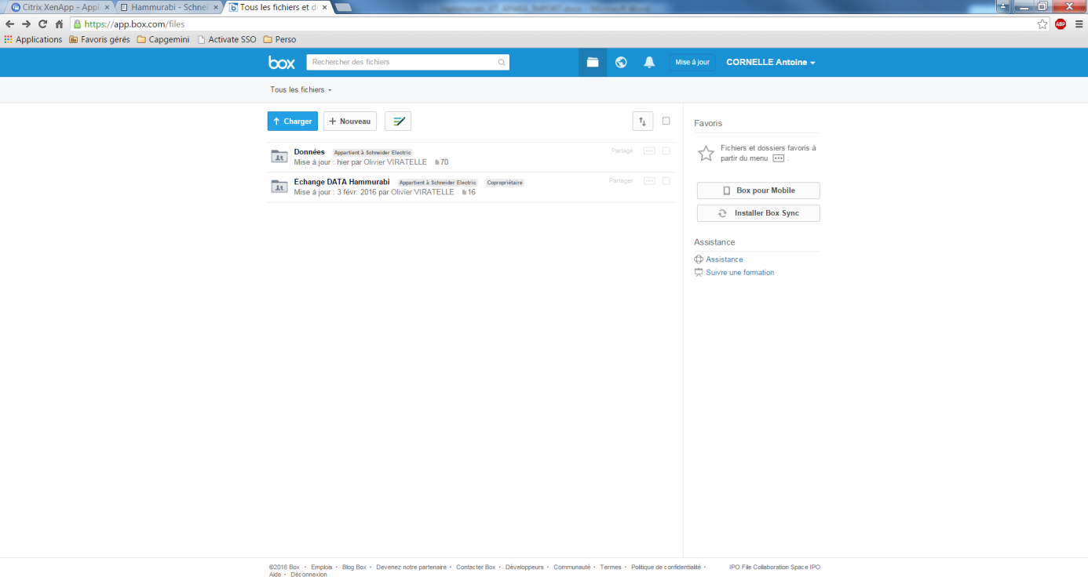

3. Click on « RDO APARA » folder

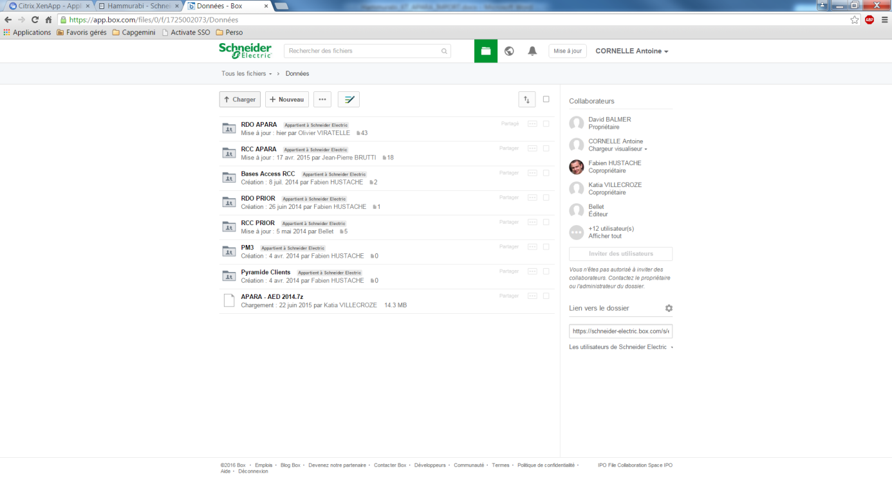

4. Search the file to import (Generally the last modified) and check on the title if it corresponds to the month and the year that the key user wants you to import. Click on this file.

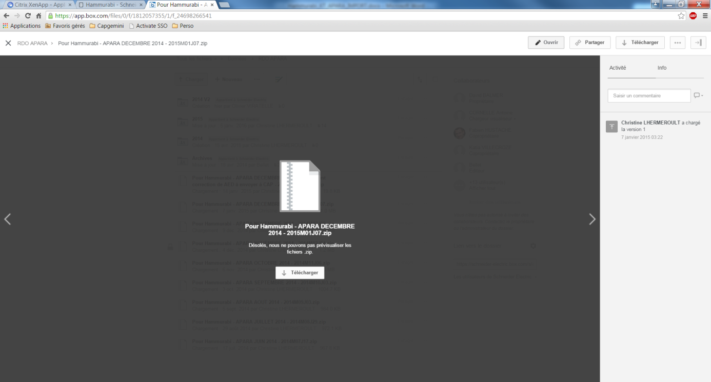

5. Click on “Download” button.

6. Extract the zip file.

7. Go on the folder extracted. There is a .txt file. Rename it to have a .csv.

### Import the data to Hammurabi INTEGRATION

1. Go to [**http://hammurabiint.fr.schneider-electric.com/**](http://hammurabiint.fr.schneider-electric.com/)

**2.** Go on Administration tab 🡪 Données de référence 🡪 Chiffres d’affaires



3. Click on « Import manuel des CA N » button



4. Choose your file and click on “Open” button

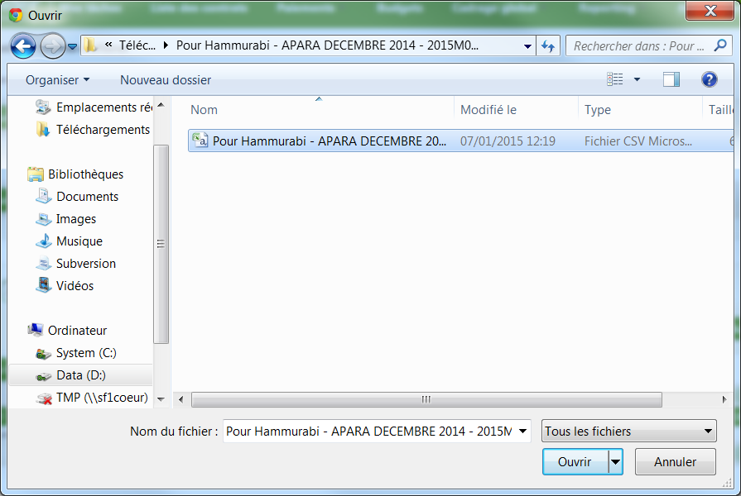

The loading begins. This operation can last up to 15 minutes.



5. When the operation is finished, refresh the page. If the import is OK, you’ll see the new date of modification (today).



6. Go on the hidden page: <http://hammurabiint.fr.schneider-electric.com/hammurabi/faces/hidden/hidden.xhtml>

7. Click on “Réinitialiser les CA projetés” button.



When the action is finished, the progress bar is at 100% and a popup is displayed



8. Send an email to the key user (Natacha BLONDIN) to say her that the import in INTEGRATION is finished.

### Import the data to Hammurabi PRODUCTION

**When you have the confirmation of the key user to import the file in production and ONLY when you have this confirmation**, do the same think in production like you have done in INTEGRATION.

URL: [**http://hammurabi.fr.schneider-electric.com/**](http://hammurabi.fr.schneider-electric.com/)

**ID: sesa111852 / soleil**

**Hidden page:** <http://hammurabi.fr.schneider-electric.com/hammurabi/faces/hidden/hidden.xhtml>

When it is finished, send an email to the key user (Natacha BLONDIN) to say her that the import in PRODUCTION is finished.

## Turnover N-1

### Get the data

1. Go on the box: <https://app.box.com/login>

2. Click on « Données » folder



3. Click on « RDO APARA » folder



4. Search the file to import (Generally the last modified) and check on the title if it corresponds to the PRIOR turnover that the key user wants you to import.

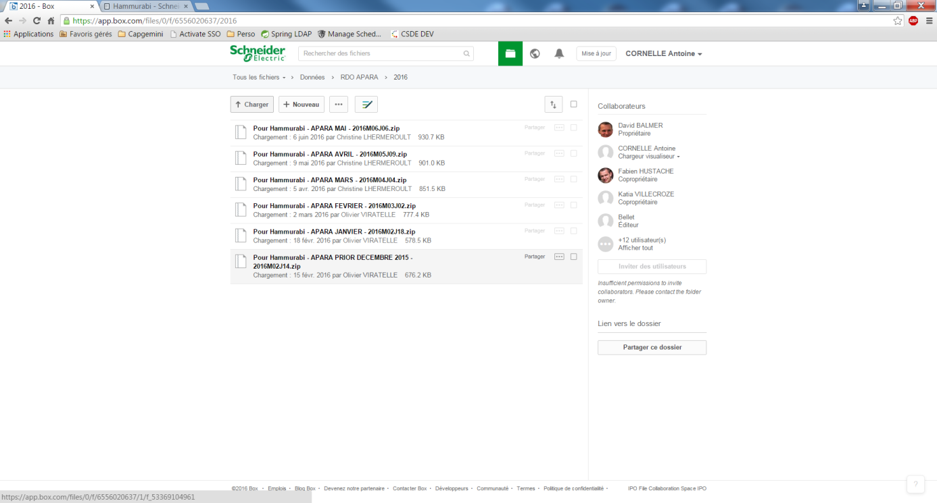

5. Click on this file.

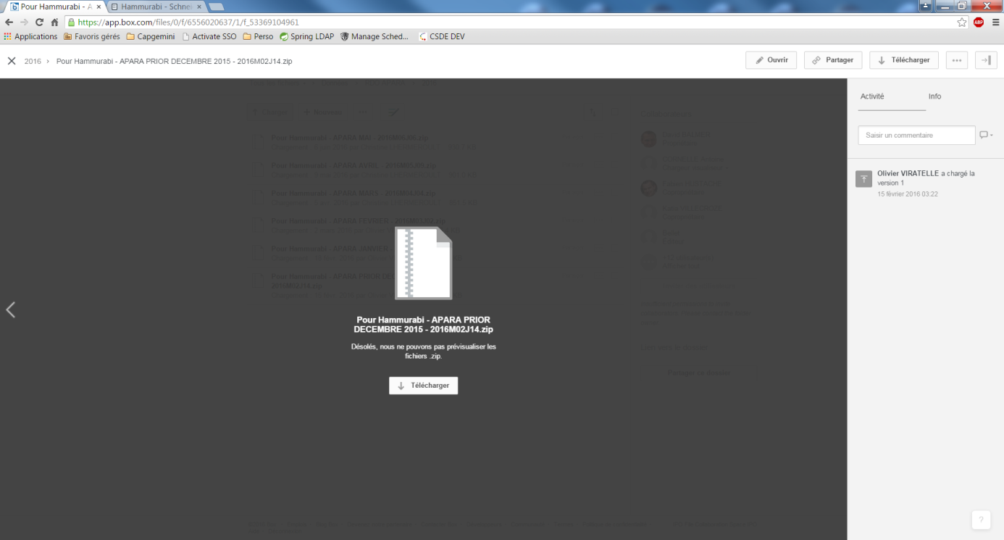

6. Click on “Download” button.

7. Extract the zip file.

8. Go on the folder extracted. There is a .txt file. Rename it to have a .csv.

### Import the data to Hammurabi INTEGRATION

1. Go to [**http://hammurabiint.fr.schneider-electric.com/**](http://hammurabiint.fr.schneider-electric.com/) (Admin user)

2. Go on Administration tab 🡪 Données de référence 🡪 Chiffres d’affaires



3. Click on « Import manuel des CA N-1 & N-2 » button



4. Choose your file and click on “Open” button



The loading begins. This operation can last up to 15 minutes.



5. When the operation is finished, refresh the page. If the import is OK, you’ll see the new date of modification (today).



6. Go on the hidden page: <http://hammurabiint.fr.schneider-electric.com/hammurabi/faces/hidden/hidden.xhtml>

7. Click on “Réinitialiser les CA projetés” button.



When the action is finished, the progress bar is at 100% and a popup is displayed



8. Send an email to the key user (Natacha BLONDIN) to say her that the import in INTEGRATION is finished.

### Import the data to Hammurabi PRODUCTION

**When you have the confirmation of the key user to import the file in production and ONLY when you have this confirmation**, do the same think in production like you have done in INTEGRATION.

URL: [**http://hammurabi.fr.schneider-electric.com/**](http://hammurabi.fr.schneider-electric.com/)

**ID: sesa111852 / soleil**

**Hidden page:** <http://hammurabi.fr.schneider-electric.com/hammurabi/faces/hidden/hidden.xhtml>

When it is finished, send an email to the key user (Natacha BLONDIN) to say her that the import in PRODUCTION is finished.

# Sellout Import

As for turnover, sellout need to be updated each month (N) and each year (N-1)

## Instructions

Each month we receive email to inform new data for sellout are available. When Hammurabi key user send the GO, we can start procedure to update them.

## Sellout N

The aim of this import is to update sellout of the current year. We need to update them monthly.

### Get the data

We get data from CDS, thanks procedures on Hammurabi database.

/!\ You need an Oracle version which propose the delimited export like the following example.

/!\ You need an Oracle with the decimal delimiter “,”

#### Execution of the SQL procedure

To extract the data, you have to execute the following SQL request in Hammurabi PRODUCTION database (/!\ You must change the value in yellow by the month and the year you want update)

execute EXTRACT_SELLOUT_N('2018', '11');

This procedure get data from CDS and put it on table on Hammurabi database.

#### Get the data in the table

Execute the following command to get the data.

select * from T_EXTRACT_SELLOUT_N

order by CODEFC, GDF;

Right click on the generated table and click on export

About the export:

* Format: delimited
* Header: YES
* Delimiter: “;”
* Left delimitation: nothing
* Right delimitation: nothing

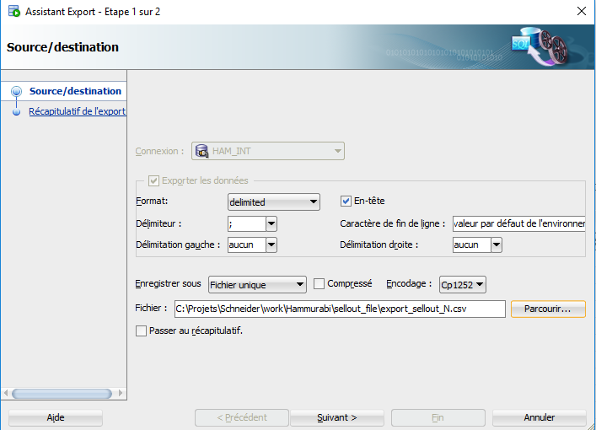

**/!\ The file must be saved with the extension “.csv”**

**Note :- open the export_sellout.csv file and replace the . with ,**

### Import the data to Hammurabi INTEGRATION

1. Go to Hammurabi INT with admin user: <http://hammurabiint.fr.schneider-electric.com/>
2. Go on Administration tab 🡪 Données de référence 🡪 SellOut

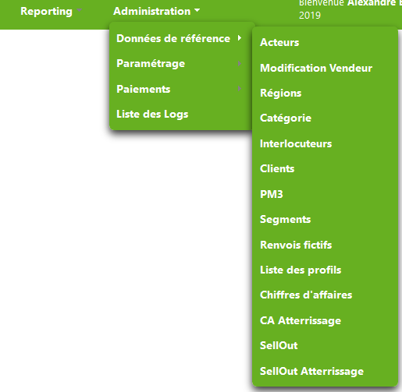

1. Click on « Import manuel des SellOut N » button

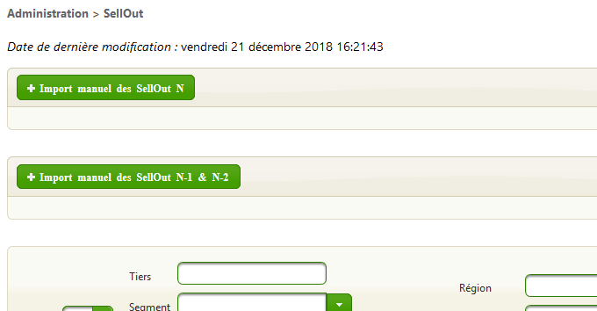

1. Choose your file and click on “Open” button

The loading begins in backgroud. This operation can last several hours, and you can follow process in log on IFRXHAM1: /schneider/hammurabiint/logs/hammurabi.log

$ cd /schneider/hammurabiint/logs

$ tail -f hammurabi.log

There are 2 main parts on this import:

* Import sellout

*****start of importCSV**********

…

Total time 122842 ms

*****End of importCSV**********

* Refresh sellout

*******start Sellout refresh ********

…

*******End Sellout refresh ********

1. When first part is finished, you can go back to sellout page. If import is OK, you’ll see the new date of modification.

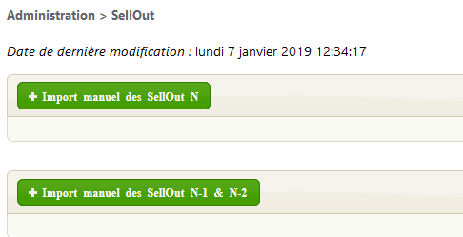

You can also access functional log via “Administration > Liste des logs”

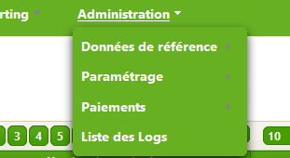

On this screen, you can see how many lines were well imported and number of errors. Name is the same for import sellout N and import sellout N1: “Import SellOut”.

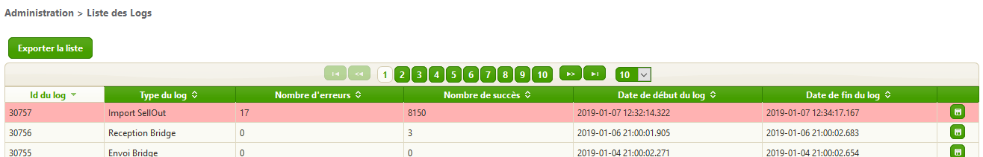

From here you can also download the final log file of the import operation for checking errors.

Example:

Date/heure;Type Message;Date/heure (format Excel);Numero Bdp;Message;Numero ligne

[ImportError(row=2, column=5, messageKey=import.gdf.notexists, refBdP= , messageParams=[]),

ImportError(row=3, column=5, messageKey=import.gdf.notexists, refBdP= , messageParams=[]),

ImportError(row=4, column=5, messageKey=import.gdf.notexists, refBdP= , messageParams=[]),

ImportError(row=8399, column=1, messageKey=import.sellout.monthnotvalid, refBdP= , messageParams=[])]

In this case, there are 2 kinds of error:

* import.gdf.notexists about product Hammurabi doesn’t know. This error is very common due to products like ‘TAMC’: You can inform key user about it.
* import.sellout.monthnotvalid about issue with month. At the end of the year, if this issue is only on the last line, it can be a bad log du to frozen landing period.

1. After all operation (import and refresh) are completed, send an email to the key user (Natacha BLONDIN) to say her that the import in INTEGRATION is finished.

### Import the data to Hammurabi PRODUCTION

When you have the confirmation of the key user to import the file in production **and ONLY when you have this confirmation**, import the same file in **Production** like you have already done in Integration (3.3.2).

Production application is available at this url:

<http://hammurabi.fr.schneider-electric.com/>

Production logs are available on this server:

PFRXHAM1

When it is finished, send an email to the key user (Natacha BLONDIN) to say her that the import in PRODUCTION is finished.

## Sellout N-1

The aim of this import is to update sellout of the **previous year**. We need to update them **once a year**.

### Get the data

We get data from CDS, thanks procedures on Hammurabi database.

/!\ You need an Oracle version which propose the delimited export like the following example.

/!\ You need an Oracle with the decimal delimiter “,”

#### Execution of the SQL procedure

To extract the data, you have to execute the following SQL request in Hammurabi PRODUCTION database (/!\ You must change the value in yellow by the year you want update)

execute EXTRACT_SELLOUT_N1('2018');

This procedure get data from CDS and put it on table on Hammurabi database.

#### Get the data in the table

Execute the following command to get the data.

select * from T_EXTRACT_SELLOUT_N1

order by CODEFC, GDF;

Right click on the generated table and click on export

About the export:

* Format: delimited
* Header: YES
* Delimiter: “;”
* Left delimitation: nothing
* Right delimitation: nothing



**/!\ The file must be saved with the extension “.csv”**

**Note :- open the export_sellout.csv file and replace the . with ,**

### Import the data to Hammurabi INTEGRATION

1. Go to Hammurabi INT with admin user: <http://hammurabiint.fr.schneider-electric.com/>
2. Go on Administration tab 🡪 Données de référence 🡪 SellOut



1. Click on « Import manuel des SellOut N-1 & N-2 » button



1. Choose your file and click on “Open” button

The loading begins in background. This operation can last several hours, and you can follow process in log on IFRXHAM1: /schneider/hammurabiint/logs/hammurabi.log

$ cd /schneider/hammurabiint/logs

$ tail -f hammurabi.log

There are 2 main parts on this import:

* Import data

*****start of importCSV**********

…

Total time 122842 ms

*****End of importCSV**********

* Refresh sellout

*******start Sellout refresh ********

…

*******End Sellout refresh ********

1. When first part is finished, you can go back to sellout page. If import is OK, you’ll see the new date of modification.



You can also access functional log via “Administration > Liste des logs”



On this screen, you can see how many lines were well imported and number of errors. Name is the same for import sellout N and import sellout N1: “Import SellOut”.



From here you can also download the final log file of the import operation for checking errors.

1. After all operation (import and refresh) are completed, send an email to the key user (Natacha BLONDIN) to say her that the import in INTEGRATION is finished.

### Import the data to Hammurabi PRODUCTION

When you have the confirmation of the key user to import the file in production **and ONLY when you have this confirmation**, import the same file in **Production** like you have already done in Integration (3.3.2).

Production application is available at this url:

<http://hammurabi.fr.schneider-electric.com/>

Production logs are available on this server:

PFRXHAM1

When it is finished, send an email to the key user (Natacha BLONDIN) to say her that the import in PRODUCTION is finished.

